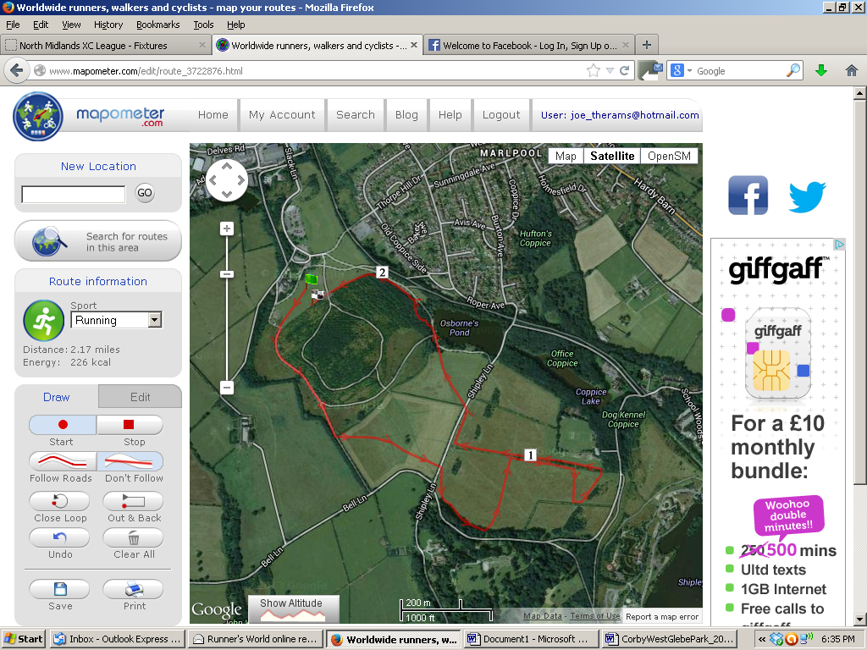
A
D
B
C
FINISH
START
CLUB TENTS
PRESENTATION AREA FIRST AID MERCHANDISE
E
LARGE LAP – START, A, B, C, D, E,

MEDIUM LAP – START, A, B, D, E,

SMALL LAP – START, A, B, E

MINOR LAP – START, A, E
REGISTRATION + RESULTS
TOILETS + CAFE
MINOR LAP: START – A – E -FINISH
SMALL LAP: START – A – B – E - FINISH
MEDIUM LAP: START – A – B – D – E - FINISH
LARGE LAP: START – A – B – C – D – E - FINISH

