It was in the spring of 2000 that Rob Rainsford finally managed to persuade me to join Heanor Running Club. I’d been a runner before, completing a couple of London Marathons in 1992 and 1994 and other local races but my love of the sport had dwindled. This was partly I now know due to not being in a club. Or more specifically, a club like this one.
Working with Rob, at Rolls-Royce in Hucknall, as we did back then, gave him plenty of opportunity to talk me back in to running. And so with a certain amount of trepidation, I crossed the border from Nottingham and met up with my new club, meeting as we did then in the Visitor Centre Car Park. And 20 years later, I’m still here!
My first time pulling on the yellow and blue vest was in a BDL race, this one being the long forgotten Black Horse 5 mile (two laps taking in High Lane). Other races followed and I remember my first Northern Cross Country at Allestree Golf Club with mud like I’d never seen.
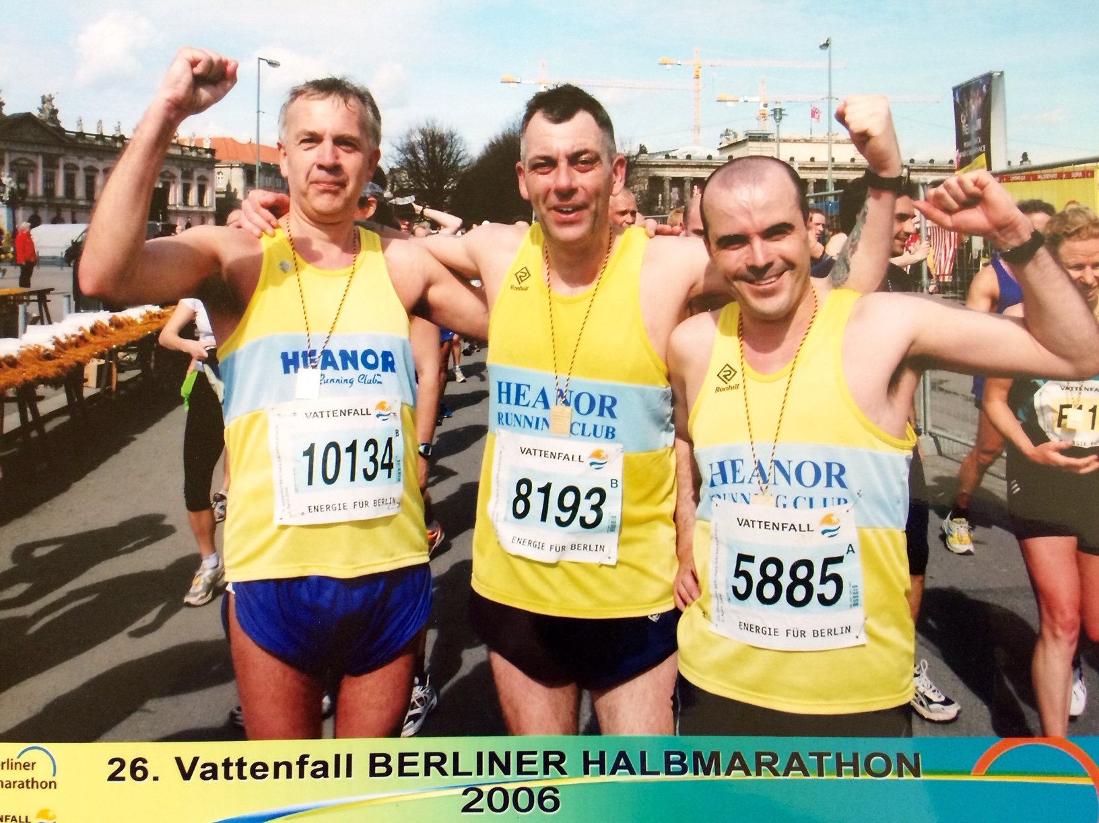
After a few years I then helped the club organise trips abroad taking in Prague a few times, Berlin, Antwerp, and Warsaw with responsibility for booking what proved to be a varying standard of hotels (I think this led me to becoming Treasurer for a few years before handing over to Yvonne). These were good trips with some fast times on flat course and, invariably, large glasses of refreshing beer.
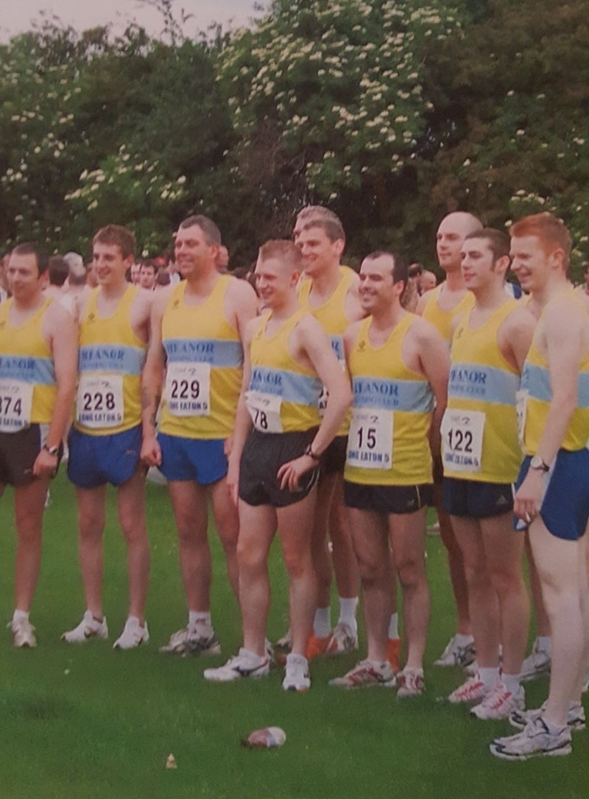
With Rob and Lee Perkins as Chairman and Secretary the club started to grow during this period. And as the club grew so we gradually become more competitive in the spring and autumn road relays.
Back then we competed in the Northern region with many a trip to the far flung north including Blackpool, Hartlepool (5K up and down the sea front!), Sunderland and more. After a few years of getting closer to that elusive top 25, the club finally made it in 2008 finishing an impressive 14th on a day of mixed April weather (those who ran in the blizzard will surely remember it!) at the Catterick Garrison, possibly my proudest moment in the yellow and blue vest.
Relays feature quite heavily in my time with Heanor RC. 2 miles flat out at the Pride Park Relays or the Washland Relays in Burton, both events which the club had a fine record at (my only win as a runner was at the Washland Relays, running 3rd leg with Chris Rainsford, Darren Ridout and Jon Wainwright) and of course, the spring and autumn road relays. The spirit within this club means that, though not many really want to run the long leg, they will, and they’ll be encouraged round and know that their efforts are genuinely appreciated.
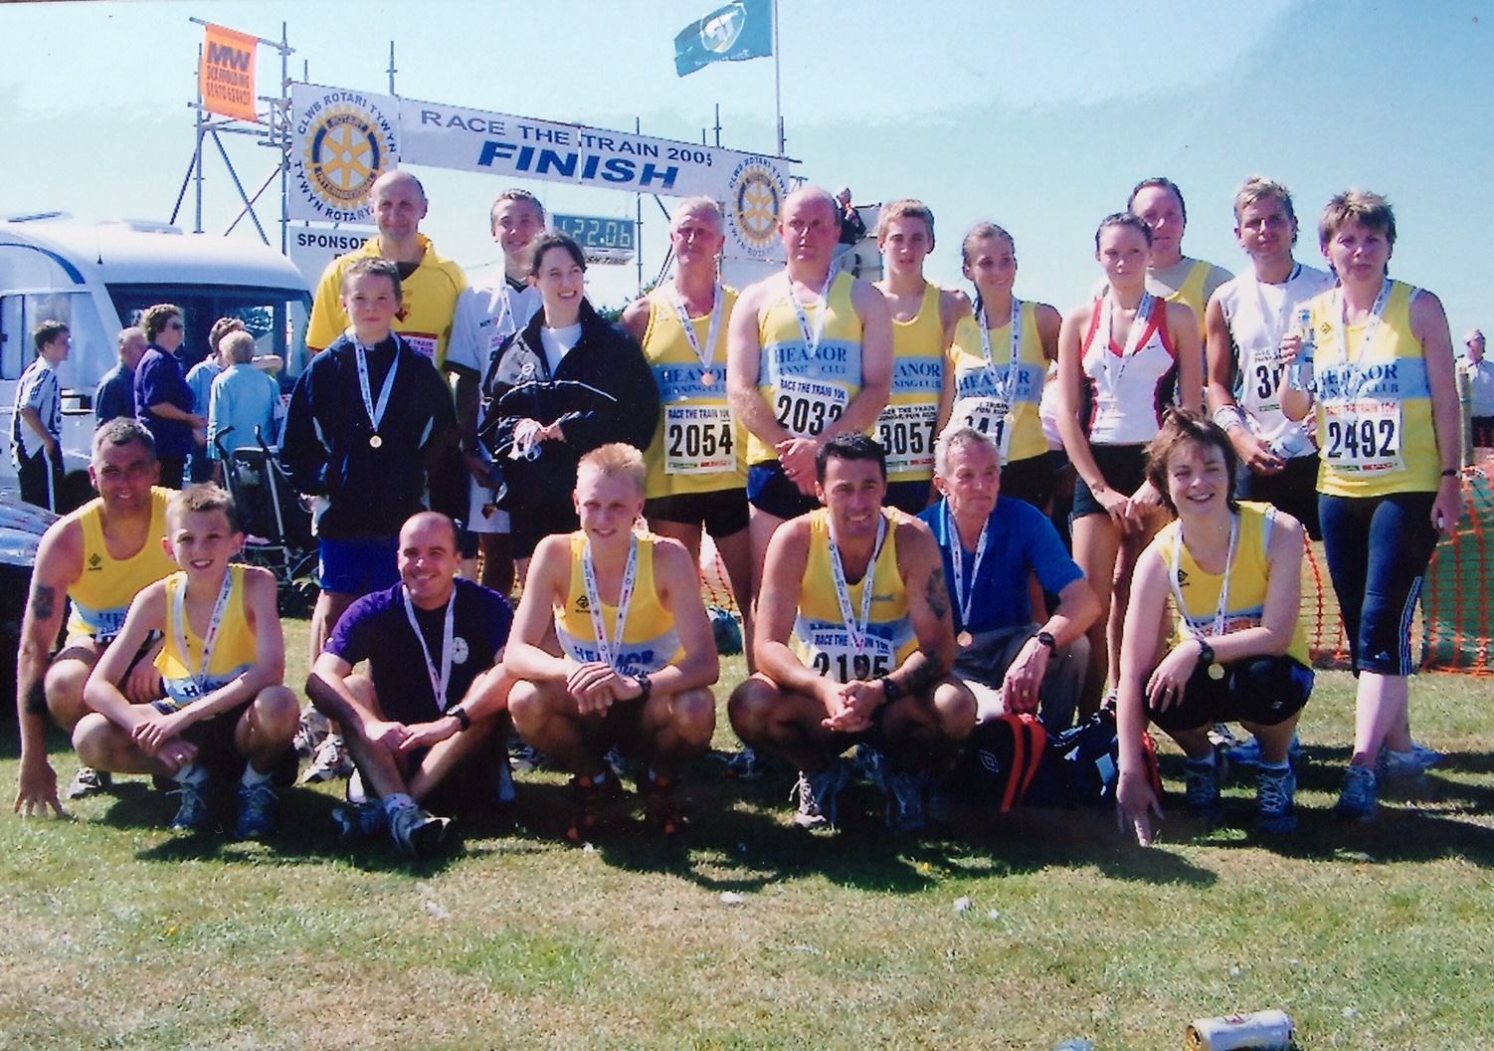

Though not the keenest of campers, I really enjoyed the club trips to Race the Train in Wales, though I preferred the run to the camping and can proudly undefeated against the Train (10K only!).
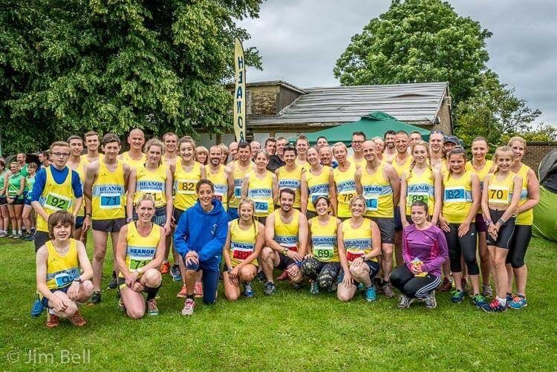
Whilst not many faces remain from when I joined back in 2000, the atmosphere around the club and team spirit is as good as it ever was. Thanks for talking me into it Rob!

