Hi fellow lions/lionesses.
I used to run for a rival club but left due to the lack of motivation. I spent a few months in the running wilderness but I got talking to an ex member whom suggested that I join HRC .I joined in summer 2002 and I found the members at the time to be friendly and helpful during training. I learnt an awful lot about interval training and pace judgement which I never really did before.
Rob Rainsford was the coach even that far back 😉. He likes to see commitment from everyone in training which is not a lot to ask when he works out the sessions for us to do so we improve as athletes. You know the sessions are tough but it's what makes you stronger and faster. It is only a Tuesday and a Thursday so the rest of the week you can run if so desired. There is a lot of fun and friendly banter within the club. No one is safe regardless of your ability! There are a number of people who will dish it out: Eamon, Joe, Ash, Rob, Shane, Paige, Jayne and Jo to name a few 😃.
The most enjoyable session is the parlaaf, especially when you see people trying to hide (myself included) so not to be paired with the quicker guys. It never works though!
I've done 321 races in the mighty yellow and blue so far but there is one race which I will probably never be allowed to forget, the National cross country 2020 at Wollaton Park. My worst race ever slowing to 10:23 last mile and finishing almost last but believe me; I have improved since then – honest!
My best races were the 2005 Pride Park Relays. 2 miles and a P.B. 10:32. The other is the 2004 BDL Summer League race at Denby Pottery finishing 3rd whilst battling with fellow members Adam Grice and Chris Rainsford and beating both of them. Wonder what ever happened to them.
For me the club offers value for money, especially when you learn how much other clubs charge! You get a training plan worked out for you if you want one. Entry into regional and national events and a select number of relay races are all free (pay a fee if you enter and don’t run) There are great days out at the 6 and 12stage relays cheering on your fellow team mates. Everyone at club is treated equal no prima donnas. You will be a victim of the banter regardless of your ability - I should know! I’m still that victim, just because I'm one of a couple of people whom speak proper English (pet).
But overall the club has the feel of an extended family that has your back and there is always someone there for you if needed to help with training, some company on your runs or if you’re feeling down and need someone to just talk to. The only thing that lets me down is the lack of numbers on training nights 20/30on some nights then drops to 6/7 - disappointing.
We now have a very good junior section with some very promising coaches to help with their development.
I think the clubs future looks bright. HRC has a very good hardworking committee who put a lot of time and effort into the club making it a very successful one. With the help of its members we can put on very successful races, from regional championships to the Pud Run. Everyone mucks in and makes it a great event for the participants.
Although I have to admit I nearly packed it all in on 2 occasions due to injuries getting me down and running slower and slower. But a chat with a couple of members, Joe and Ash (plus the mojo group I was in) really helped me. Plus the new members in the club putting the work in on speed sessions when they’re not able to attend club nights through social media gave me a good kick up the backside (if they can do it there’s no reason I can’t ). Now I'm back to my young self again loving my training, running fast again just waiting to race.
#HTiD

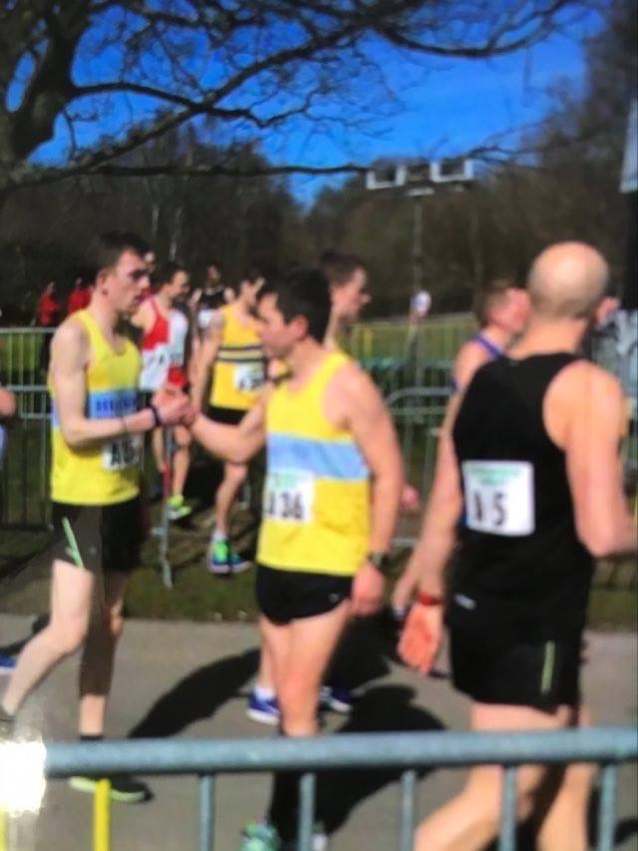

Tony Weatherson

